**1U72-ACY**

**Structural based cavity detection for C1 1U72 PROTEIN And ligand ACY**

| **CurPocket ID** | **Cavity volume (Å3)** | **Center (x, y, z)** | **Cavity size (x, y, z)** |
| --- | --- | --- | --- |
| **C1** | 2008 | 32, 16, 2 | 15, 22, 17 |
| **C2** | 224 | 17, 8, 11 | 15, 6, 9 |
| **C3** | 207 | 17, 21, -10 | 10, 8, 7 |
| **C4** | 195 | 13, 1, 0 | 12, 6, 6 |
| **C5** | 164 | 22, 10, -17 | 9, 7, 5 |

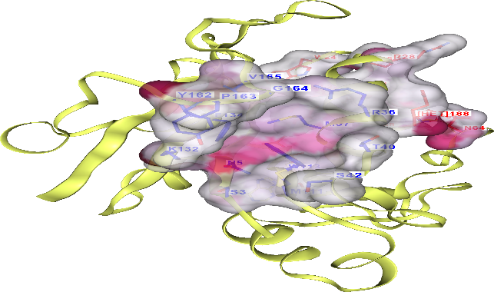 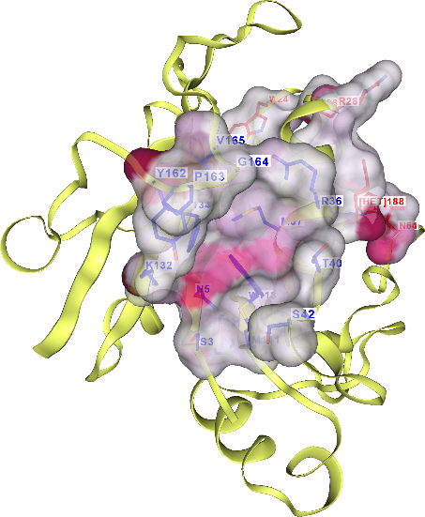

C1 C2

C3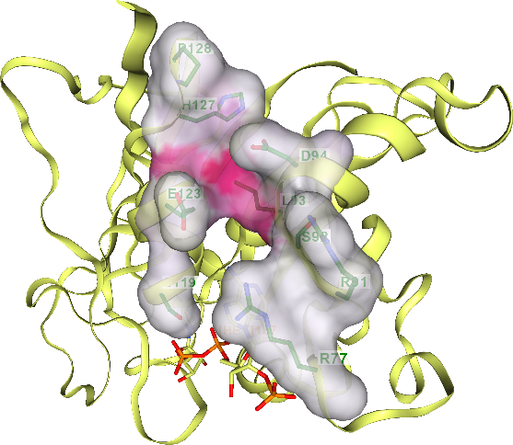

C5 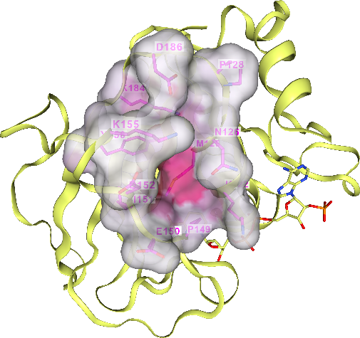

**CY Docking to DHFR (1U72): Updated Pocket Ranking**

|  |  |  |  |  |  |  |  |  |  |  |  |  |  |  |  |  |  |  |  |  |  |  |  |  |  |  |  |  |  |  |  |  |  |  |  |  |
| --- | --- | --- | --- | --- | --- | --- | --- | --- | --- | --- | --- | --- | --- | --- | --- | --- | --- | --- | --- | --- | --- | --- | --- | --- | --- | --- | --- | --- | --- | --- | --- | --- | --- | --- | --- | --- |
| | **Cavity ID** | **Vina Score (kcal/mol)** | **Volume (Å³)** | **Center (x, y, z)** | **Size (x, y, z)** | **Interpretation** | | --- | --- | --- | --- | --- | --- | | **C1** | –3.1 | 2008 | (32, 16, 2) | (20, 27, 22) | **Best overall**: largest volume, strong binding score | | **C5** | –3.1 | 164 | (22, 10, –17) | (14, 14, 14) | Small pocket, same score; likely hydrophobic | | **C2** | –2.7 | 224 | (17, 8, 11) | (20, 14, 14) | Narrow cavity; moderate fit | | **C4** | –2.5 | 195 | (13, 1, 0) | (14, 14, 14) | Compact; weaker binding | | **C3** | –2.3 | 207 | (17, 21, –10) | (14, 14, 14) | Least favorable score | |

**Pocket:C1 and Score -3.1**

**Chain A: ALA9 LEU22 TRP24 PRO25 PRO26 LEU27 GLU30 PHE31**

**Verdict: C1 is the best docking pocket**

* It has the **lowest Vina score** (–3.1) and the **largest volume**, making it ideal for flexible or polar ligands like ACY.
* **C5** has the same score but a much smaller volume, so it may suit small hydrophobic ligands like butane.
* **C2–C4** show weaker scores and smaller volumes, suggesting less favourable binding.

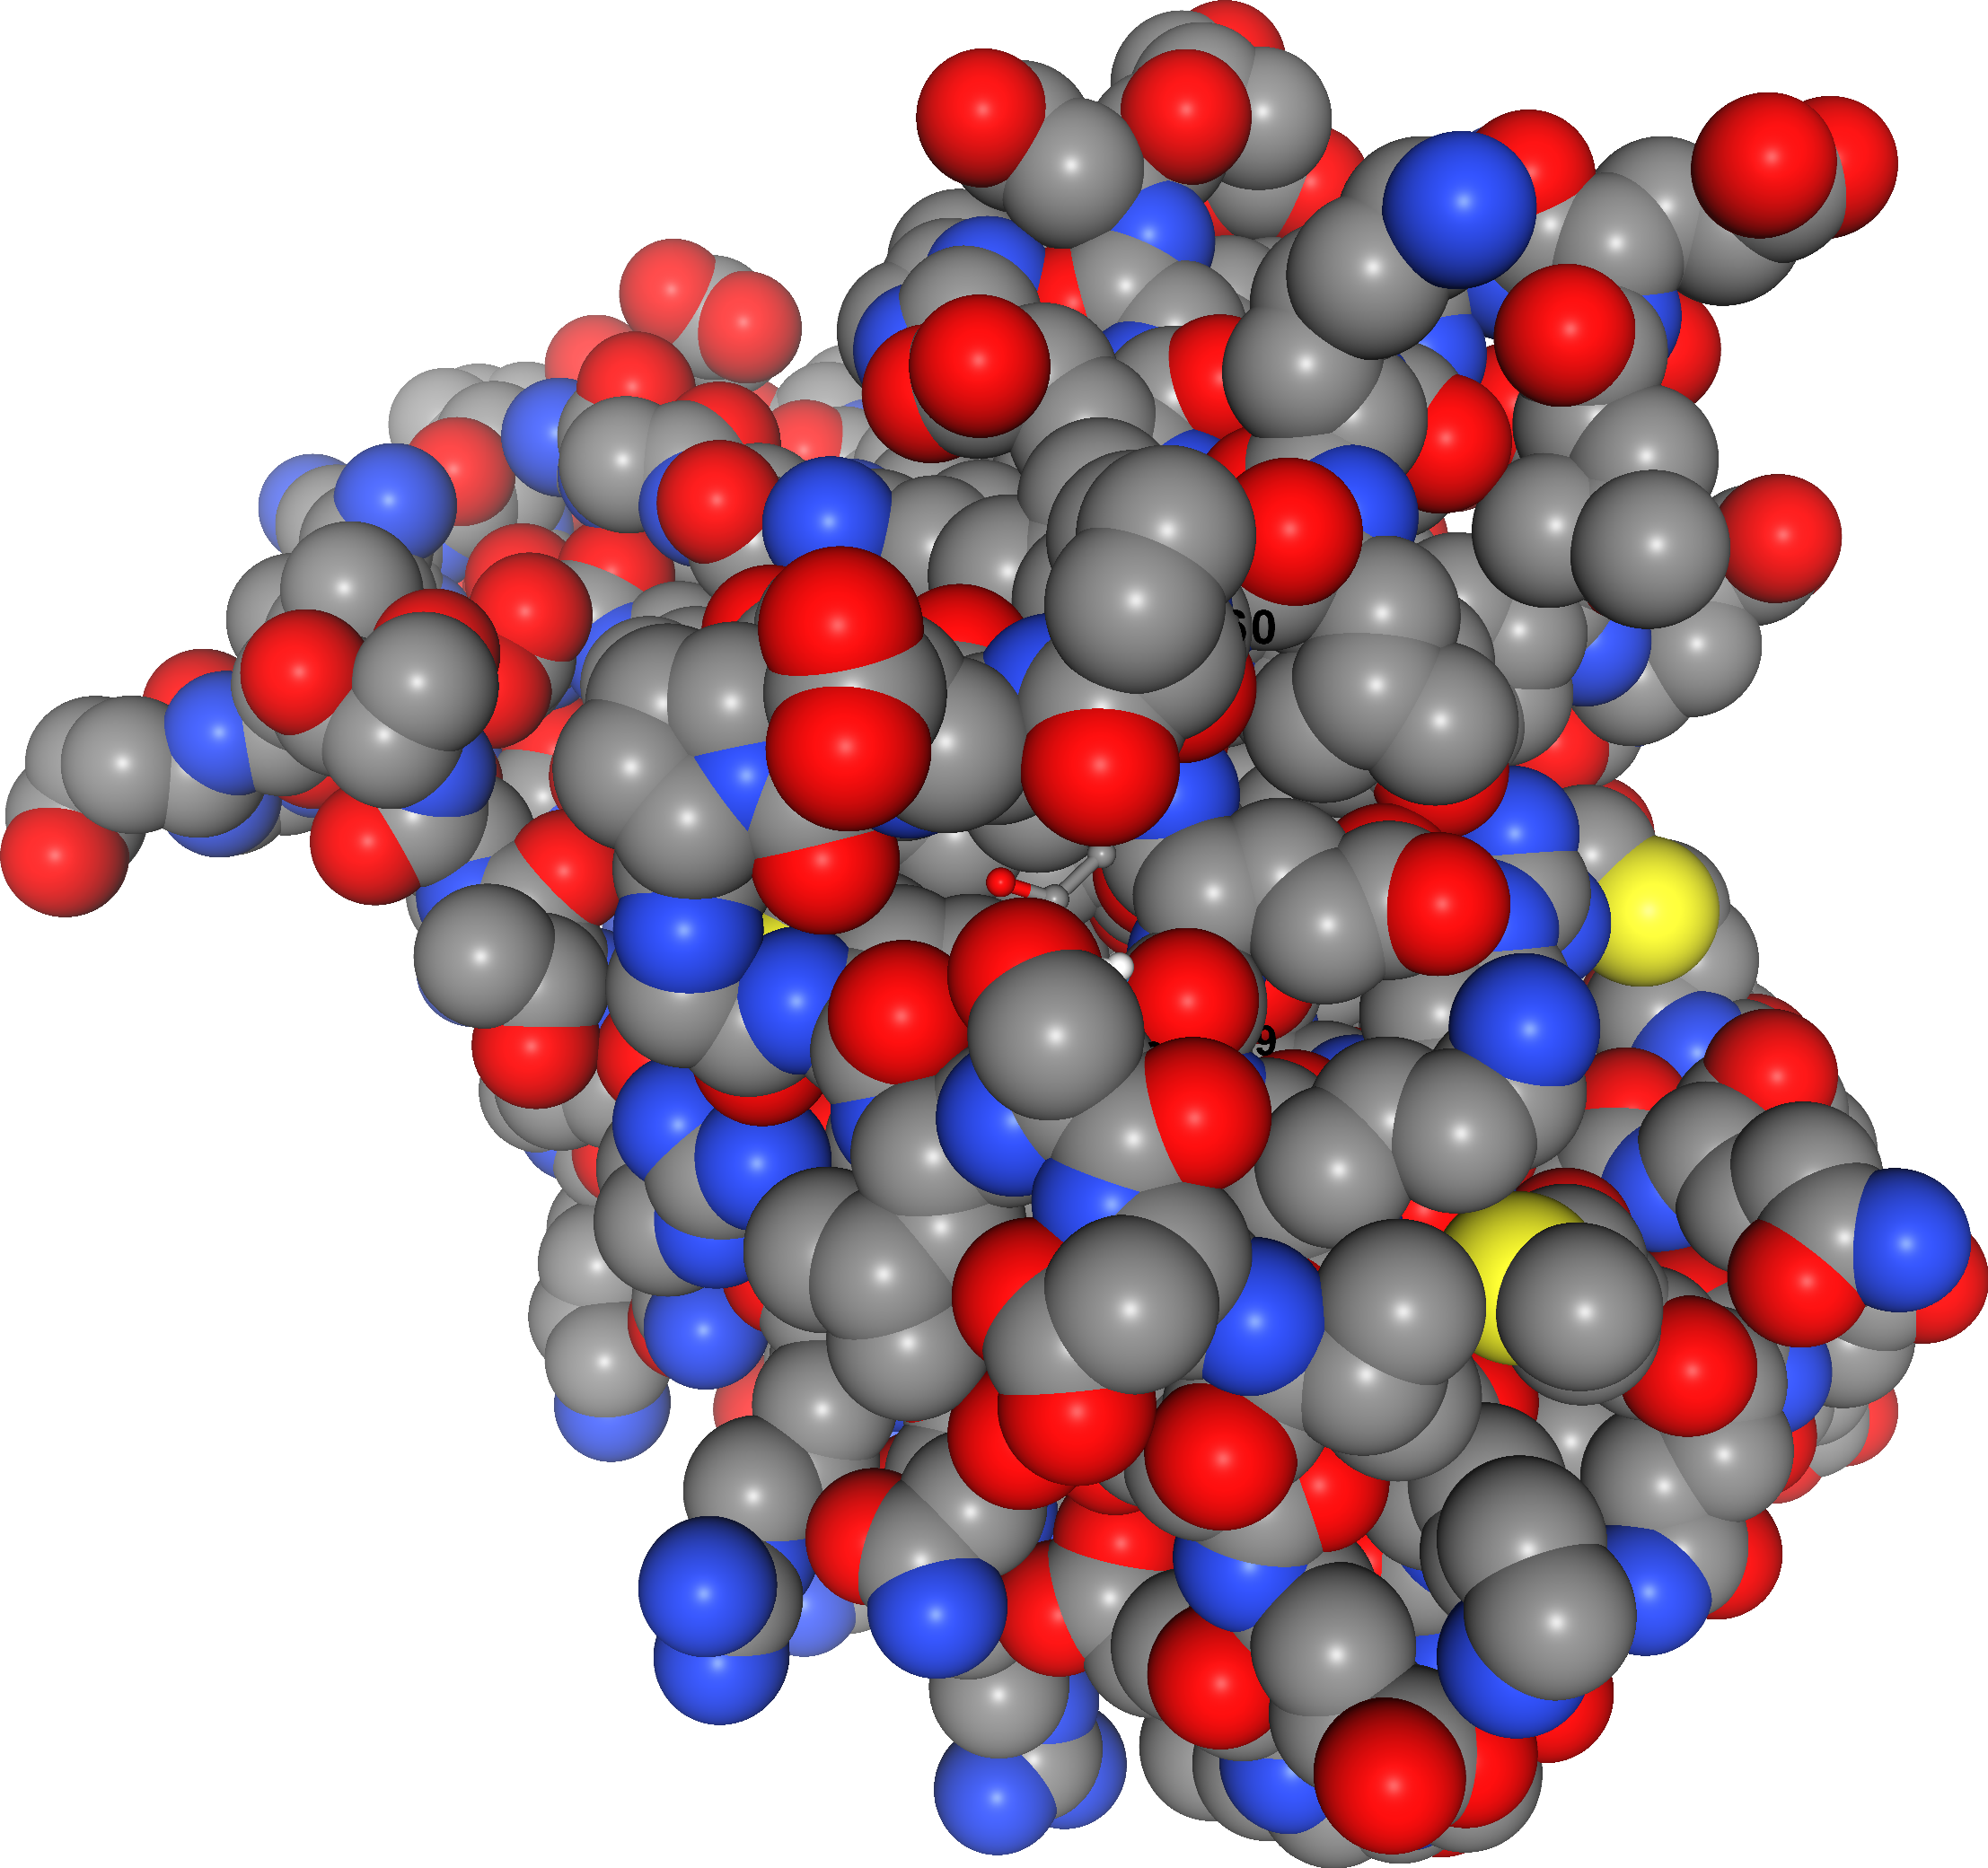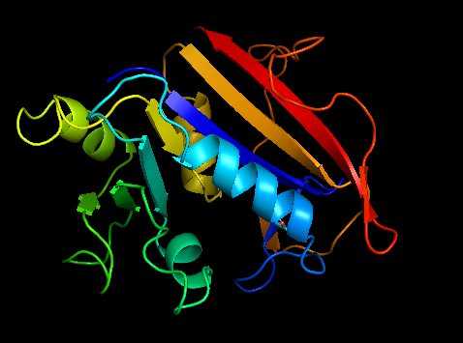

**Fig.2.Ribbon View Docking Pymol**

**Fig1.Space-filling molecular model**

**of the protein-ligand complex—CB-Dock2**

**Space-filling molecular model of the protein-ligand complex—specifically, the result of your CB-Dock2 docking run with ACY (or butane) docked into 1U72, the human DHFR protein.**

**Here’s what it shows:**

* **Protein atoms are rendered as spheres, each colored by element:**
  + **Gray = Carbon**
  + **Red = Oxygen**
  + **Blue = Nitrogen**
  + **White = Hydrogen**
  + **Yellow = Sulphur**
* **The ligand (ACY or butane) is nestled inside one of the detected cavities (likely C1, based on your docking scores), showing how it fits spatially into the binding pocket.**
* **This space-filling model emphasizes steric complementarity—how well the ligand’s shape matches the cavity’s contours.**

**🧠 Why This Is Useful**

* **Helps visualize binding interactions (hydrophobic fit, hydrogen bonding zones, steric clashes)**
* **Useful for infographic export in ChemInsight Lab**
* **Can be used to compare poses across cavities (e.g., ACY in C1 vs C2)**
* **Ideal for GUI integration or educational outreach**